**Assignment 2**

**1. Write query to select all the columns of emp table**

**Query:** select * from HR.employees

**Output:**

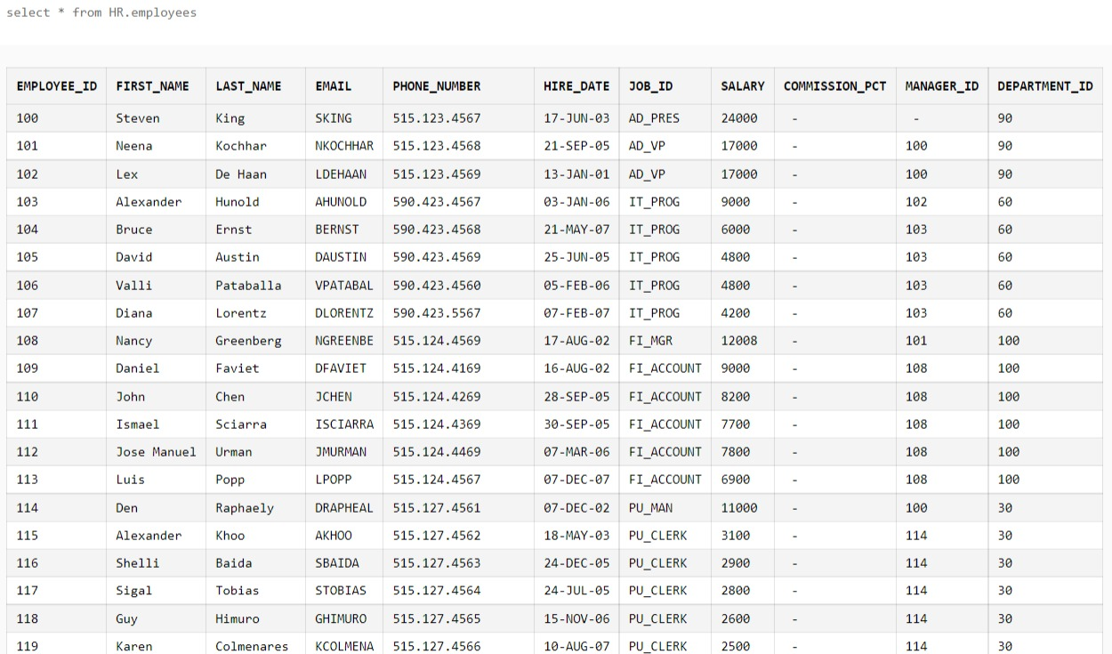

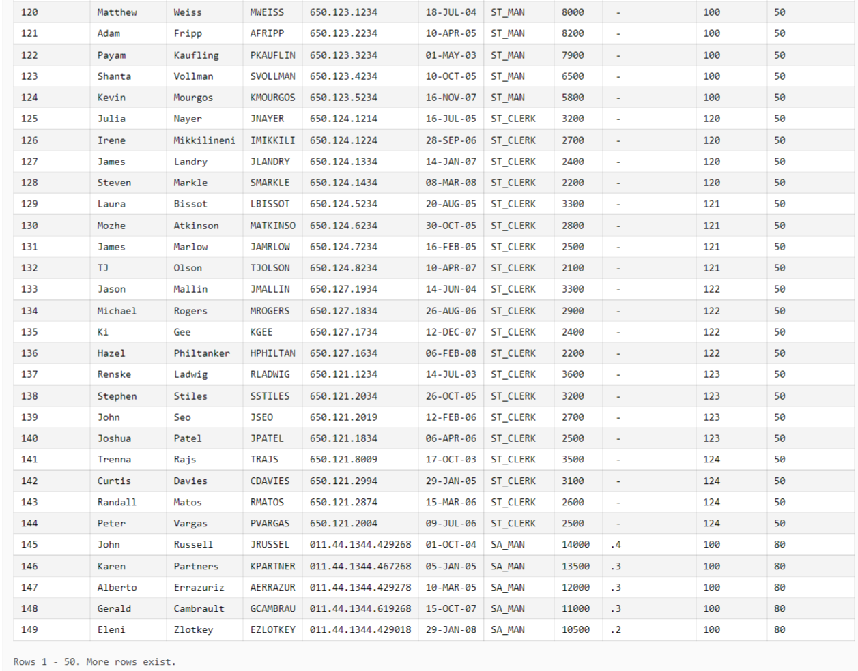

**2. Write query to select only Employees name, id and Job**

**Query:** select FIRST_NAME,EMPLOYEE_ID,JOB_ID from HR.employees

**Output:**   
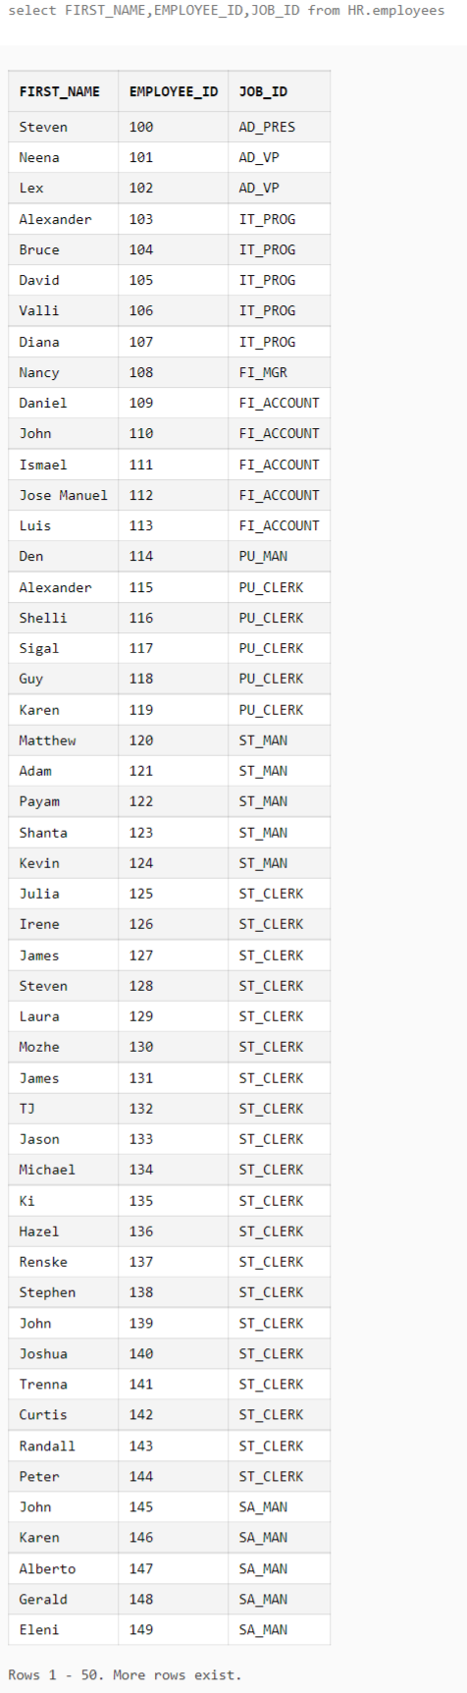

**3. Write query to select unique Jobs.**

**Query:** select DISTINCT(JOB_ID) from HR.employees

**Output:**   
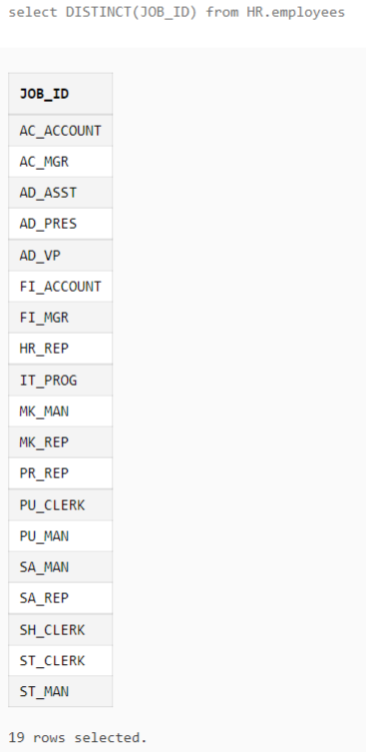

**4. Write query to select only those employees who have job ‘ST_Clerk’.**

**Query:** select FIRST_NAME from HR.employees where JOB_ID IN('ST_CLERK')

**Output:**   
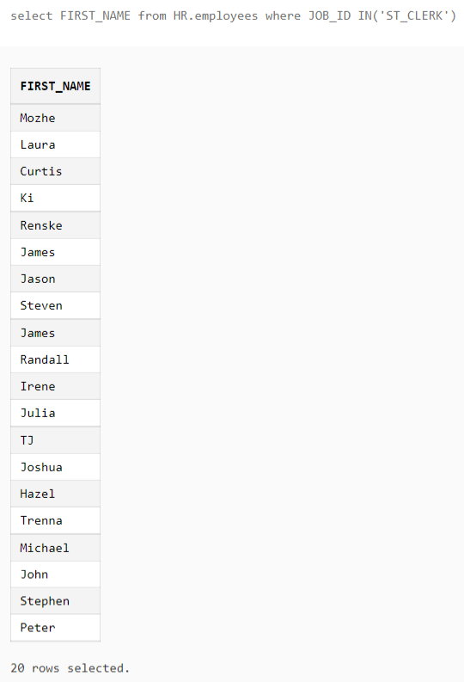

**5. Select employee name, grade and salary, in the order of their salary.**

**Query:** select FIRST_NAME, SALARY FROM HR.employees ORDER BY SALARY

**Output:**

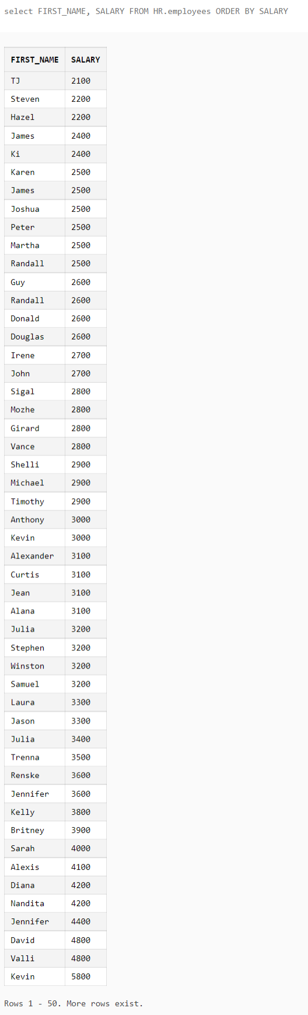

**6. Create tables cust2 without values of cust1 using CTAS statement**

**Query:** create table cust2 as

(select * from HR.employees

)

**Output:**

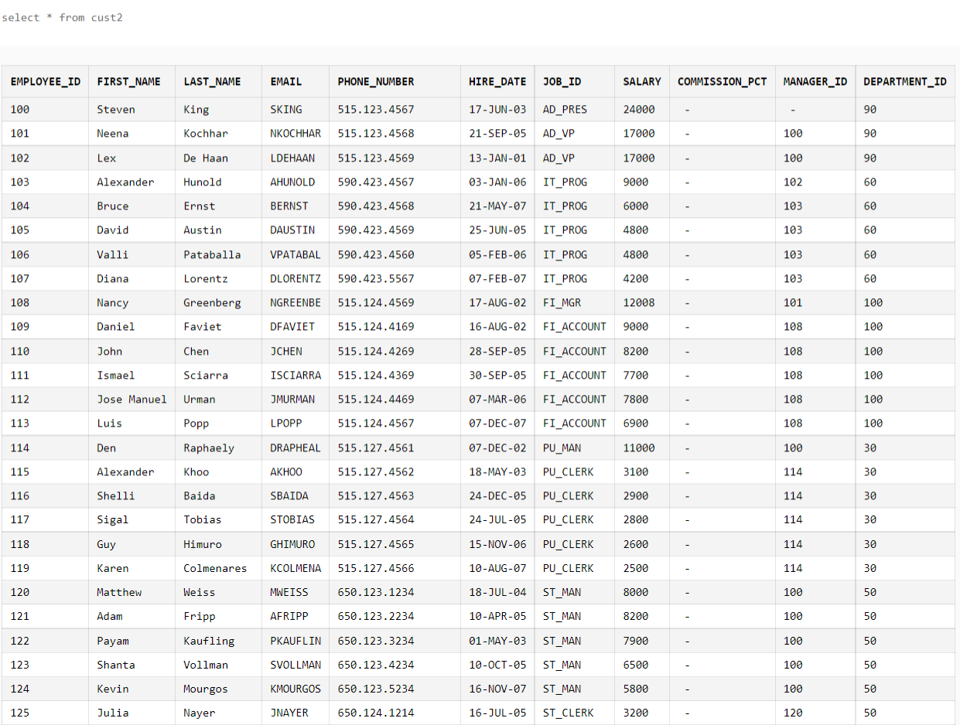

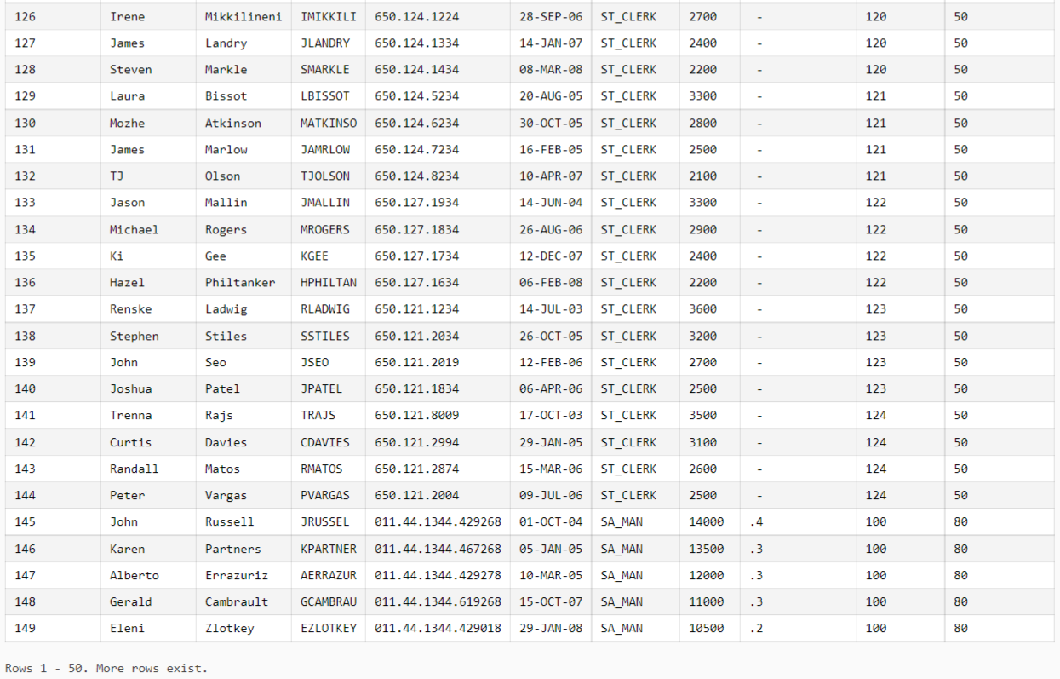

**7. Mgmt. is considering a pay raise, however they want to find out, if they give a flat 200/- increment to all, then what % each person is getting. So in your result display, ename , salary and pctincr**

**Query:** SELECT FIRST_NAME, SALARY, (((SALARY+200)-SALARY)/SALARY)*100 pctincr from HR.employees **Output:**

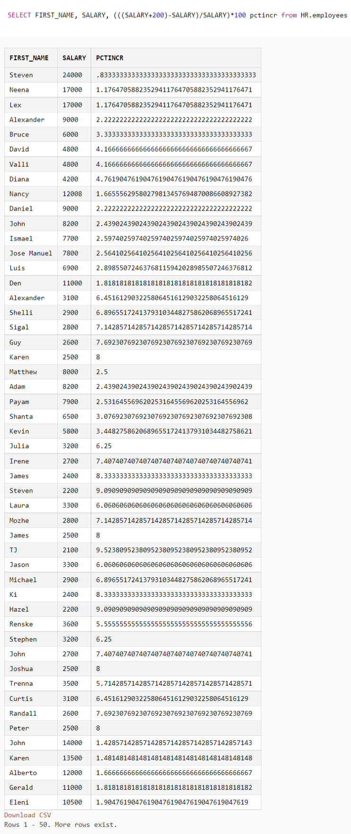

**8. Express work experience of each of the employees by using sysdate and hiredate in terms of no of years. Hints : you would need to use cast**

**Query:** SELECT MONTHS_BETWEEN (sysdate, HIRE_DATE) from HR.employees;

**Output:   
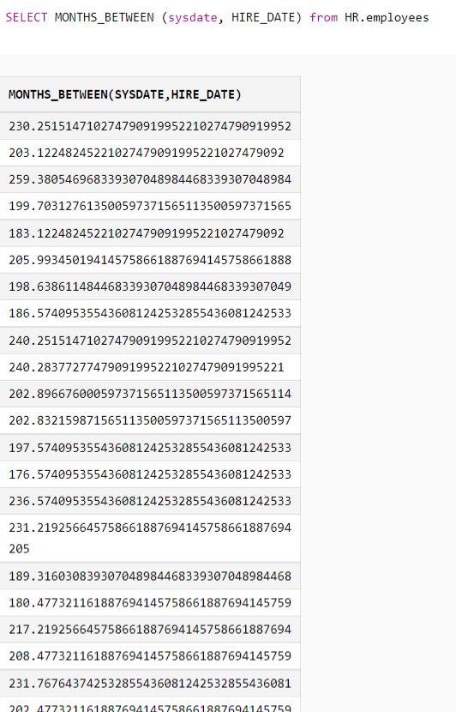**

**9. Select only those employees who are a clerk and a manager**

**Query:** select * from HR.employees WHERE JOB_ID IN ('ST_CLERK', 'ST_MAN');

**Output:**

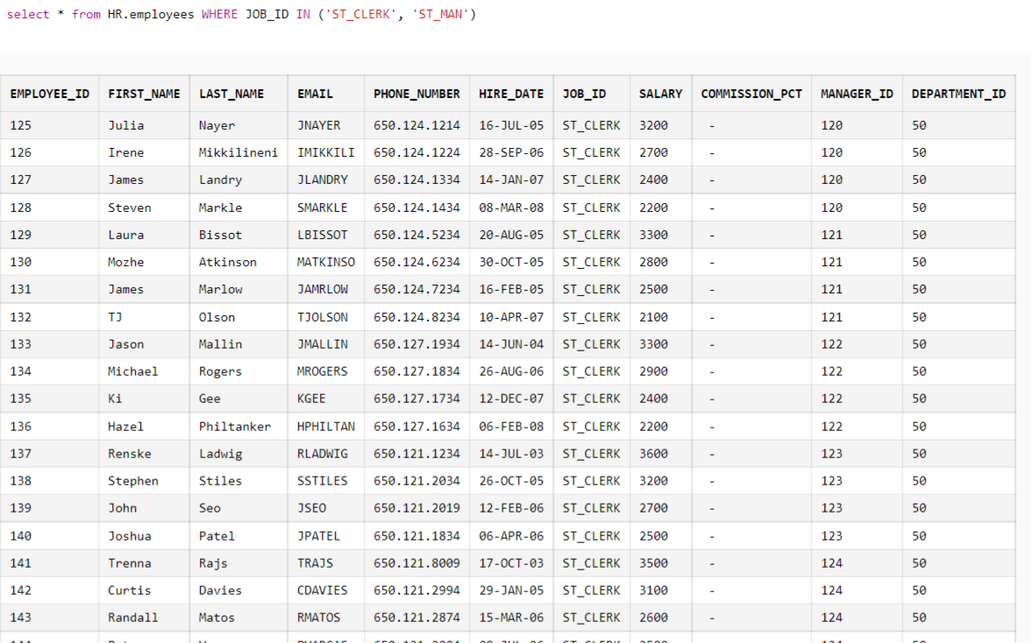

**10.** **Use emp table and use different columns and string concatenation to display a message like below for each of the employees Output Example : JAMES is a CLERK and is working in the company for last 32 Years**

**Query:** select FIRST_NAME || 'is a' || JOB_ID || ' and is working in the company since ' || HIRE_DATE from HR.employees

**Output:  
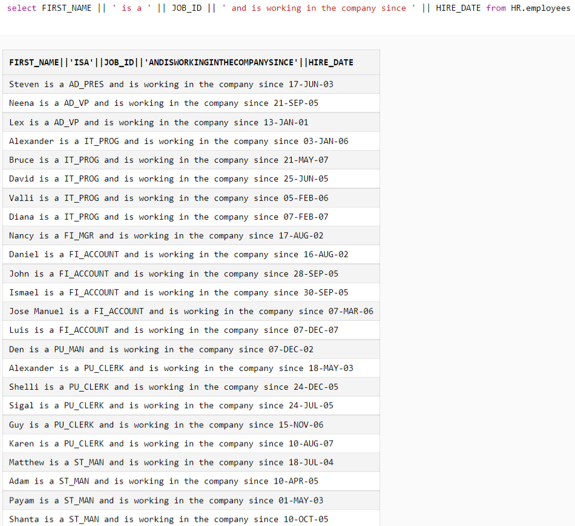**

**11. Use emp table to display only those employees who have joined in the year 2000 and 2008.  
Query:** SELECT *FROM HR.employees WHERE to_char(hire_date, 'yyyy')='2000' OR to_char(hire_date, 'yyyy')='2008' **Output:**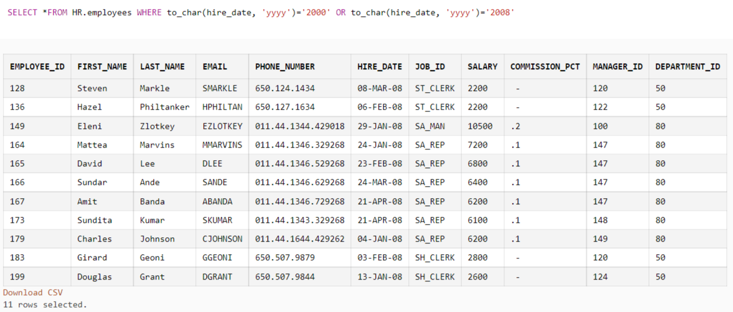

**12. Use like statement to display name of the employees and their id which start with ‘A’  
Query:** Select EMPLOYEE_ID, FIRST_NAME from HR.employees where FIRST_NAME like 'A%’  
**Output:**   
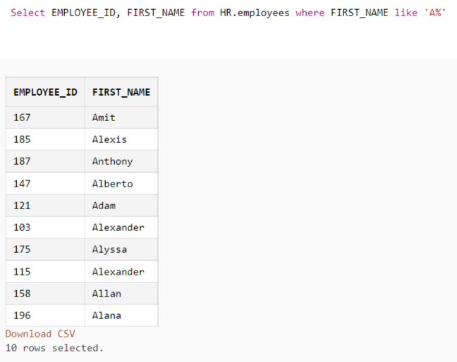

**13. Select those employees, who has joined on or before 31st December 2000 and is either a clerk or having a salary greater than 2500  
Query:** select FIRST_NAME from HR.employees where HIRE_DATE<='31-DEC-00' and (JOB_ID in ('ST_CLERK') or SALARY>2500);

**Output:**

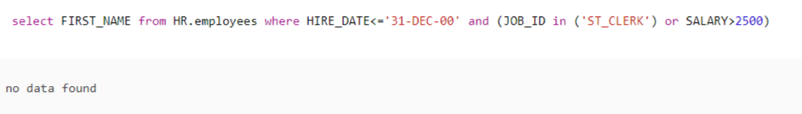

**14. Convert the string ‘Kolkata’ into its upper case and ‘MUMBAI’ to its lower-case value  
Query:** SELECT UPPER('Kolkata'),LOWER(‘Mumbai’) FROM HR.employees  
**Output:  
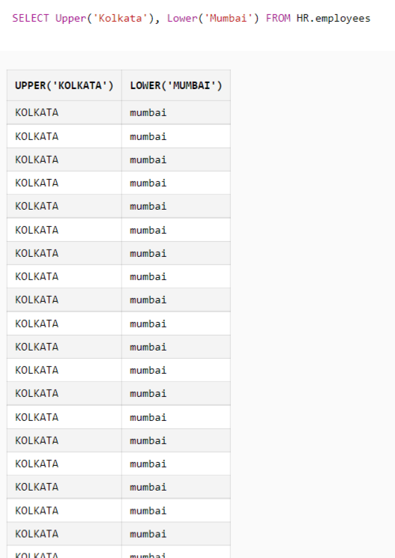**

**15. Display name of your institute in all Upper-Case  
Query:** SELECT UPPER('Institute of Engineering and Management') from HR.employees

**Output:  
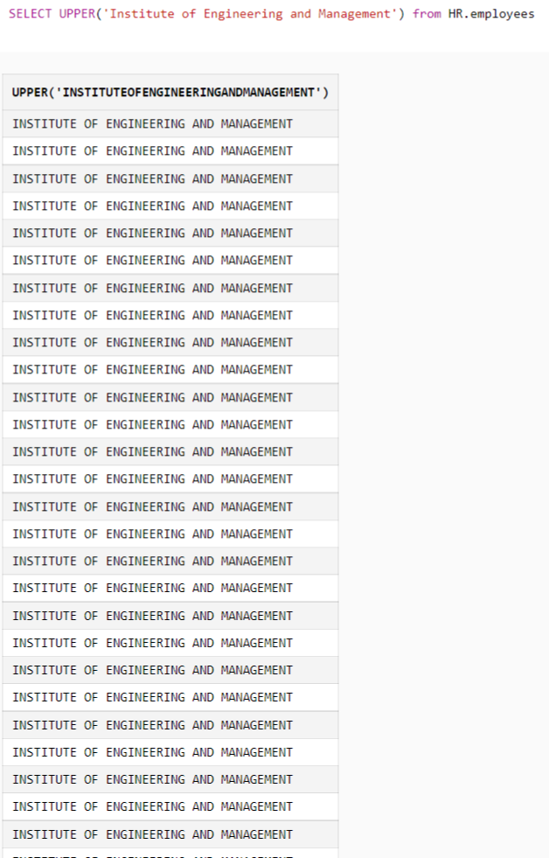**

**17. Display day, month and year of the hire date of employee.**

**Query:** select FIRST_NAME,HIRE_DATE from HR.employees  
**Output:**  
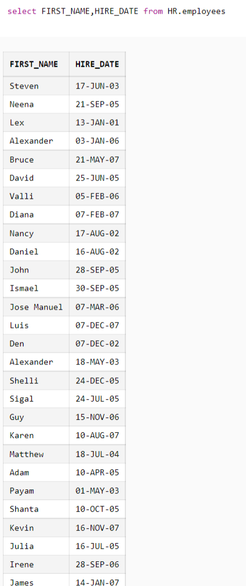

**18. Display the last name of the employees in a manner, so that they are right-aligned**

**Query:** select rtrim(LAST_NAME,' ') from HR.employees **Output:   
